ANDE GAYATHRI

18-8-22/9E, MADHURA NAGAR Tirupati, Andhra Pradesh, India - 517501

EMAIL: [gayathriande20@gmail.com](mailto:gayathriande20@gmail.com) CONTACT: 9618574968

LINKEDIN URL: [www.linkedin.com/in/ande-gayathri-9b536524a](http://www.linkedin.com/in/ande-gayathri-9b536524a)

**CAREER OBJECTIVES:**

Aspiring software developer seeking an internship opportunity to apply academic knowledge in computer science and develop practical skills in software development. Eager to contribute to innovative projects and learn from experienced professionals in a dynamic tech environment.

**EDUCATION:**

**SRI VENKATESWARA COLLEGE OF ENGINEERING, Tirupati 2021-2025**

**B. TECH [CSM(AI&ML)]**

* AGGREGATE: 86.8%

**SRI CHAITANYA JUNIOR COLLEGE, Tirupati 2019-2021**

**INTERMEDIATE [M.P.C]**

* AGGREGATE: 75.6%

**SRI VENKATESHWARA CHILDREN’S HIGH SCHOOL 2019**

* AGGREGATE: 95%

**SKILLS:**

* Strong organizational and time-management skills
* Exceptional communication and interpersonal skills
* Ability to work independently and as part of a team
* Basics in Java (Oops concept)
* Basics in SQL
* Proficient in Figma
* Scripting languages: HTML, CSS, JAVASCRIPT
* Basics in Python
* Basics in C

**CERTIFICATIONS:**

* Course Completion of Google Sheets Built in Udacity.
* Completion of MySQL Training program at Bodha Software Technologies Private Limited.
* Completion of C and Data Structures Training program at Bodha Software Technologies Private Limited
* Completed the Mastering Figma: Beginner to Expert UI/UX Design course.
* Obtained an edX Verified Certificate for Python Basics for Data Science from edX.
* Obtained an edX Verified Certificate for HTML5 and CSS Fundamentals from edX.

**ACHIEVEMENT:**

* Participated in POSTER PRESENTATION IIC 6.0 conducted in SVCE.
* participation in the "Bharatiya Kala Pratiyogita" The Online Art Competition of Bharat.
* Winner of the Art & Painting Event, National Educational Day, Sri Venkateswara College of Engineering (SVCE), November 27, 2023.
* completed the Dr. B.R. Ambedkar Quiz, organized by the Ministry of Social Justice and Empowerment & MyGov.

**PERSONAL DETAILS:**

|  |  |
| --- | --- |
| **DATE OF BIRTH** | 20-02-2004 |
| **GENDER** | FEMALE |
| **FATHER NAME** | ANDE SIVAIAH |
| **MOTHER NAME** | ANDE PRASANNALAKSHMI |
| **ADDRESS** | 18-8-22/9E,Madhura Nagar,(near fish market)Tirupati  Pincode-517501 |

**DECLARATION:**

* I hereby declare that the above-written particulars are true and correct to the best of my knowledge and belief

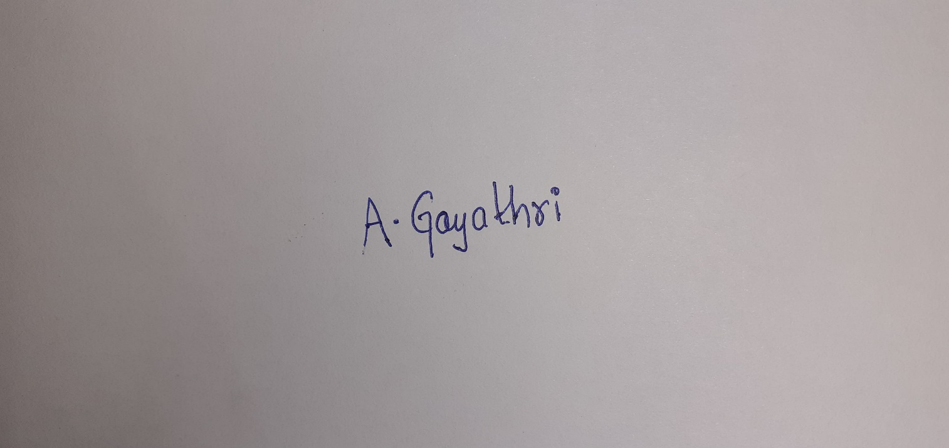

**ANDE GAYATHRI**